**CS5590/490 Python-DeepLearning**

**Python**

**LAB**

**Assignment-2**

**Submitted by: Shajee Uddin Zain Mohammed**

**Student ID: 16230179**

**Class ID: 28**

1. **Consider a shop UMKC with dictionary of all book items with their prices. Write a program to find the books from the dictionary in the range given by user.**

**Source Code:**

fiction = {**'Nancy drew'**:20,**'Harry Potter'**:40,**'Ready Player one'**:10,**'Call me by your name'**:30}  
print(**"Enter a range for books to purchase"**)  
x = int(input(**"Starting value:"**))  
y = int(input(**"Ending value:"**))  
print(**"The books purchsed are:"**)  
**for** key **in** fiction:  
 **if** fiction[key]>=x **and** fiction[key]<=y :  
 print(key)

**Output:**

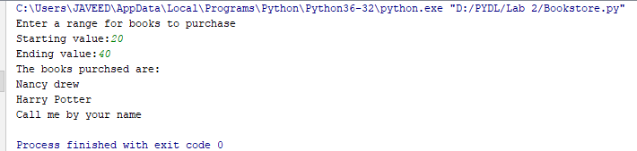

1. **With any given number n,**

**In any mobile , there is contact list. Create a list of contacts and then prompt the user to do the following:**

**a) Display contact by name**

**b) Display contact by number**

**c) Edit contact by name**

**d) Exit**

**Based on the above scenario, write a single program to perform the above the operations. Each time an operation is performed on the list, the contact list should**

**be displayed.**

**Source code:**

**from** collections **import** defaultdict  
**def** contacts():  
 print(**"1. Contact By Name"**)  
 print(**"2. Contact By Number"**)  
 print(**"3. Edit Contacts By name"**)  
 print(**"4. Exit"**)  
 print()  
contact_list =[{**"Name"**:**"Zain"**,**"Number"**:8167266155,**"Email"**:**"mohd.szain@gmail.com"**},{**"Name"**:**"Aejaz"**,**"Number"**:8162178135,**"Email"**:**"aejaz@gmail.com"**},{**"Name"**:**"Huaifa"**,**"Number"**:816420420,**"Email"**:**"autostar@gmail.com"**}]  
contacts()  
menus = int(input(**"Enter a choice of yours between 1-4: "**)) *#The action to be performed is selected here***if** menus == 1:  
 Name = str(input(**"Please enter the contact name you wish to search:"**)) *#Since the name is in string we are using Str before input* **for** a **in** contact_list:  
 **if** a[**"Name"**] == Name: *#If the name entered matches the name in the list it prints out the output* print(a)  
 **break  
 else**:  
 print(**"The name you entered not found in the directory"**)  
 exit(0)  
  
**elif** menus == 2:  
 Number = int(input(**"Please enter the number to retreive contact details:"**))  
 **for** a **in** contact_list:  
 **if** a[**"Number"**] == Number: *#It is the same thing as above since we are finding details through number* print(a)  
 **break  
 else**:  
 print(**"Check the number you have entered"**)  
 exit(0)  
  
**elif** menus == 3:  
 Name = str(input(**"Please enter the contact name to update it's details:"**))  
 **for** a **in** contact_list:  
 **if** a[**"Name"**] == Name:  
 print(a)  
 Numb = int(input(**"Enter the new number:"**)) *#Since only the number may be changed we are just updating the number* a[**"Number"**] = Numb  
 print(**"The updated details are:"**)  
 print(a)  
 **break  
 else**:  
 print(**"Please check the name you have entered"**)  
 exit(0)  
**else**:  
 print(**"Thank you"**)  
 exit(0)

**Output:**

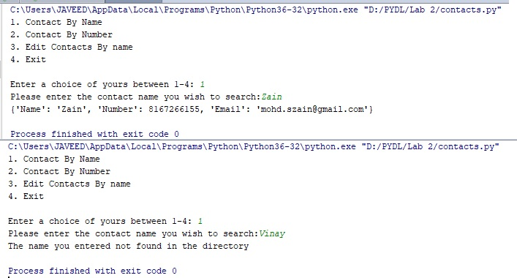

1. **Write a python program to create any one of the following management systems.**

**Expense Tracker System (classes for Expense, Transaction Category etc.)**

**Prerequisites:**

**Your code should have atleast five classes.**

**Your code should have _init_ constructor in all the classes**

**Your code should show inheritance atleast once**

**Your code should have one super call**

**Use of self is required**

**Use at least one private data member in your code.**

**Use multiple Inheritance atleast once**

**Create instances of all classes and show the relationship between them.**

**Your submission code should point out where all these things are present.**

**Source code:**

print(**" Welcome to Budget Tracker application \n Please provide your details:"**)  
name = input(**"Enter your name:"**)  
age = int(input(**"Enter your age:"**))  
number = int(input(**"Enter your contact number:"**))  
email = input(**"Enter your email address:"**)  
ssn = int(input(**"Enter your SSN:"**))  
limit = int(input(**"How much amount do you wish to track:"**))  
  
*#__init__ constructor and self are implemented in every class.  
#creating class 1***class** Details():  
 **def** __init__(self,name,age,email,number):  
 self.name = name  
 self.age = age  
 self.email = email  
 self.num = number  
  
 **def** details(self,sa):  
 self.__ssn = sa *#Making SSN as a private variable* print(**"\n Name of the person: "**, self.name + **"\n Email address: "**, self.email,**"\n Age:"**,self.age,**"\nContact number:"**, self.num,**"\nSocialsecurity number:"**, self.__ssn)  
  
*#defining class 2 from class 1  
#Inheriting classes and implementing super in this class***class** Income(Details):  
 income = 0  
  
 **def** __init__(self, name, age, email, number):  
 *# super is implemented here* super(Income, self).__init__(name, age, email, number)  
  
 **def** update_salary(self):  
 self.a = int(input(**"Enter your savings"**))  
 self.__class__.income = self.__class__.income + self.a  
 print(**"Total savings: "**, self.__class__.income)  
*#definig class 3 from class 1  
# Ineritance implemented***class** Addexpense(Details):  
 a = 0  
  
 **def** __init__(self, name, age, email, number):  
 Details.__init__(self, name, age, email, number)  
  
 **def** update_expense(self):  
 b = []  
 c = int(input(**"Enter the number of expenses you want to add:"**))  
 **for** x **in** range(0, c):  
 t = int(input(**"Add your expense here "**))  
 b.append(t)  
 print(**"List of expenses added"**, b)  
 self.exp = sum(b)  
 self.__class__.a = self.__class__.a + self.exp  
 print(**"Sum of expenses added:"**, self.__class__.a)  
  
*#definin class 4 from class 2 and class 3***class** Balance(Addexpense, Income): *#multiple Inheritance implemented* bal = 0  
 **def** __init__(self):  
 print(**"Check your balance here:"**)  
 **def** balance(self):  
 self.__class__.bal = Income.income - Addexpense.a  
 print(**"Total Savings:"**,Income.income)  
 print(**"Total Expenses:"**, Addexpense.a)  
 print(**"Amount Left:"**, self.__class__.bal)  
  
*#defining class 5 from class 4***class** Tracking(Balance):  
 **def** __init__(self, l):  
 self.tr = l  
 **if** (Balance.bal < self.tr):  
 print(**"Your remaining balance:"**,Balance.bal)  
 print(**"Your balance is less than your set limit"**)  
 **elif** (Balance.bal > self.tr):  
 print(**"Your remaining balance:"**, Balance.bal)  
  
u = Details(name, age, email, number)  
u.details(ssn)  
v = Income(name, age, email, number)*#Here Instance of a class Income 'v' is created and it extends instance of the class Details 'u'*v.update_salary() *#updating the salary of instance 'v'*w = Addexpense(name, age, email, number) *#Here the Instance of class Addexpense 'w' is created and it extends instance of the class Details 'u'*w.update_expense() *#updating the expenses of instance 'w'*x = Balance() *#Here Instance of class Balance 'x' is created and it extends instance of classes Income 'v' and Addexpense 'w'*x.balance() *#Here we are checking balancing with the instance 'w'*y = Tracking(limit) *#Here the Instance of class Tracking 'y' is created and it extends instance of the class Balance 'x'*v.update_salary()  
w.update_expense()  
x.balance()  
y.__init__(limit)

**Output:**

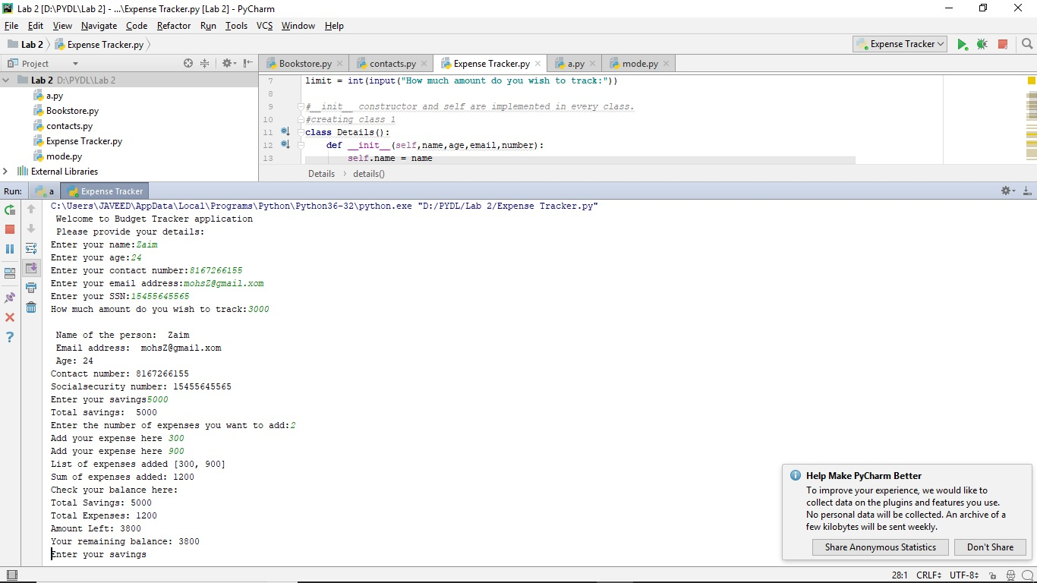

1. **Using Numpy create random vector of size 15 having only Integers in the range 0 -20. Write a program to find the most frequent item/value in the vector list.**

**Source Code:**

**import** numpy **as** x *#Using numpy Library*Y = x.random.randint(0,20,size=15) *#Creating a Vector list of 15 random numbers*print(Y)  
print(**"The most common integer in the list is:"**,x.bincount(Y).argmax())

**Ouput:**

